What is a Royal Ambassador?



Teaching Through
The Royal Ambassador Motto and Pledge

This material was developed and produced under the direction of Savion Lee, coordinator, Texans on Mission (TXM) Royal Ambassadors and Challengers,
by the Local Chapter Support Group (LCS Group)
of the TXM Royal Ambassadors and Challengers Ministry Team (RAMT).

The introduction and lessons were created and authored in a collaborative effort by the members of the LCS Group — Kirk Acheson, Mark Forester, Hadley Foster, Juan Sanchez, Murrie Wainscott, and Al Wise. The final document was compiled and edited by Elizabeth and James Bransom, co-leaders of the Technical, Communications, and Administrative Support Group (TCAS Group) of the RAMT; Stanley Smith, LCS group leader and RAMT chairman; and Lee.

Copyright ©2025 Texas Baptist Men, Inc. All rights reserved. “TBM” and “Texans on Mission” are registered trademarks of Texas Baptist Men, Inc.
“Royal Ambassadors,” “Woman’s Missionary Union,” and “WMU” are registered trademarks of Woman’s Missionary Union, Birmingham, Alabama. “RA Trek” is a service mark of Woman’s Missionary Union.
This material may be used by any group, organization, or individual for the purpose of leading, teaching, supporting, and/or promoting the Royal Ambassadors ministry.
Any and all uses other than these are strictly prohibited.
Any copies, using any media, of this material in whole or part shall include the above copyright, trademark, service mark, and use notices.
Any comments concerning these materials may be sent to
Royal Ambassadors Ministry
Texans on Mission
5351 Catron Drive
Dallas, Texas 75227
or e-mailed to Royal.Ambassadors@texansonmission.org
Table of Contents
Welcome to Royal Ambassadors 5
Lesson 1 – Royal Ambassador Motto 8
“We are ambassadors for Christ” 8
Royal Ambassador Motto 8
Reciting the Motto 9
Leader Wrap-up 10
Lesson 2 – Royal Ambassador Pledge Line 1 16
“to become a well-informed responsible follower of Christ” 16
As the boys arrive 16
Opening 16
Business 16
Meeting Feature 17
Leader time 19
Closing Prayer Time 19
Lesson 3 – RA Pledge Line 2 22
“to have a Christlike concern for all people” 22
As the boys arrive 22
Opening 22
Meeting Feature 22
Closing 23
Activity 23
Lesson 4 – Royal Ambassador Pledge Line 3 26
“to learn how to carry the message of Christ around the world” 26
Objective 26
While the boys arrive 27
Opening 27
Meeting Feature/Counselor’s Time 28
Closing 29
Additional Options 30
Lesson 5 – Royal Ambassador Pledge Line 4 34
“to work with others in sharing Christ” 34
As the boys arrive 34
Opening 34
Meeting Feature 35
Leader time 35
Closing 35
Resources 36
Lesson 6 – Royal Ambassador Pledge Line 5 38
“to keep myself clean and healthy in mind and body” 38
Bible Verse 38
Meeting Feature 38
Leader Time 39
Bible Verse Fill in the Blank 40
Word Search 40
Activity 41

This page is intentionally left blank.

Welcome to Royal Ambassadors
Thank you for your willingness to be used by God in shaping and molding young boys into becoming Godly men. In 1908, the women of the Women’s Missionary Union (WMU) saw the need for a program that would minister to boys. Throughout the history of Royal Ambassadors (RAs) there has always been a need for men who are willing to invest their time in developing and mentoring boys and young men. This can seem to be an overwhelming task at times. But remember, “Nothing is Impossible with GOD!” These start-up lessons are designed to help you begin your journey with your feet on solid ground. Remember that all leaders at some time were at the point where you are right now. Take Courage! As a wise leader once said, “You only have to stay one step ahead of the boys!”
These lessons are designed to assist the leader of a new group that is just starting. Some of this may seem overly simplified, but it is intended to help a new leader get started by providing as much help and information as possible. It is best for these lessons to be presented in sequence (1-6) to establish a firm foundation on which to build an effective and successful RA ministry. Even though they are designed more for beginning leaders, they still have value for any leader, especially when starting a new year. The information provided in these lessons will help explain the foundational concepts and beliefs of RAs. The main purpose of RAs is to share the message of Christ so that a boy accepts Christ’s invitation to follow Him and to become Christ’s ambassador.
As a general rule, most RA groups meet for a 45-60 minutes. These lessons are designed for that timeframe. We know you may not be able to complete all of a lesson in one week. Some of the individual activities toward the end of each lesson could be taken home to be finished. This might also be a ministry to other family members. You may need to take more time to finish the current lesson before continuing on to the next one. That is OK. Do whatever you think you need to do. Just remember the pace will be important to keeping the boys’ interest. You don’t want to move so slow that they lose interest, but you also don’t want to go so fast that they can’t stay with you.

You will find that these early lessons use a questioning process to encourage boys’ thinking and thought processes. The desire is that it will lead to discussion that will allow you as leader to direct their understanding of the subject. The information in italics is intended to be part of your standard back-up answers to the discussion questions. The age of your boys and their understanding of the topic will affect your response and explanation.
Be Encouraged! Jump In! You may never know this side of Glory the impact you will have on a boy’s life.

Teaching Through the Royal Ambassador
Motto and Pledge
Lesson 1 – Royal Ambassador Motto

The Royal Ambassador Motto
“We are ambassadors for Christ”
— 2 Corinthians 5:20

The Royal Ambassador Pledge
As a Royal Ambassador I will do my best:
to become a well-informed, responsible follower of Christ;
to have a Christlike concern for all people;
to learn how to carry the message of Christ around the world;
to work with others in sharing Christ; and
to keep myself clean and healthy in mind and body.

Lesson 1 – Royal Ambassador Motto

“We are ambassadors for Christ”
(Ideas for possible answers are in italics.)

Royal Ambassador Motto
“We are ambassadors for Christ,”— 2 Corinthians 5:20

What is a motto?
Ask the boys to tell you what they think a motto is. Discuss and elaborate on their responses.
- A motto is a short statement or saying that tells other people what we try to do or be.
Can they think of any? Discuss their responses.
- Police – “To protect and To Serve”
- USA – “In God We Trust” (show money to illustrate)
- US Marine Corps – “Semper Fidelis” (Always Faithful)

What does it mean to be an ambassador?
Ask the boys to tell you what they think an ambassador is. Discuss and elaborate on their responses.
- An ambassador is someone who represents another person when they cannot be at that other place. The definition often used is, “A representative of a king in the court of another.”

What does it mean to be a Royal Ambassador?
Ask them what they think this would mean? Discuss their responses.
- As a “Royal Ambassador” we are representing Jesus Christ wherever we are.

Whom do we represent?
This is somewhat repeating the previous question, but it might get them to think in a little different direction and will also reinforce the idea of what a “Royal Ambassador” is.
- We represent Jesus Christ and share his message with those people we meet.

Where do we represent Christ?
Ask the boys where are some places that they can be Christ’s ambassadors. Discuss how they can be ambassadors for Christ anywhere, anyway, and anytime.
- We are to share the message of Christ. It does not matter if we are at home, at school, in our city, in our country or even around the world.

Ambassador Role-Playing Activity
This activity is designed to reinforce the concept of an ambassador in a more hands-on manner. Use the boys’ imagination skills to personalize this time. You could change the name of the kings or their country or government (court), vary the message or even change the delivery system.
- Have one boy be called “King of Stan” and another boy be called “King of Lee.” Have the two kings sit in a chair on opposite sides of the room. A third boy (Juan) is selected by the “King of Stan” to represent him and his country to the “King of Lee”. Juan is given a very important message by the “King of Stan” to carry to the “King of Lee” inviting him to a special meal. Juan then delivers the invitation to the “King of Lee.”
- It is good if some simple props such as robes (bathrobes or old shirts), crowns (paper or fast food restaurant giveaways) and special invitation box (decorated shoebox or carrier bag) are used. This activity could be repeated several times allowing different boys to become the actors. Discuss with the boys what is the message and/or invitation we carry as Royal Ambassadors.
Leader note: There is a sample dialogue for this activity at the end of this lesson.

Reciting the Motto
One of the requirements of becoming an RA is to be able to recite the RA Motto from memory. The boy should be encouraged to stand up straight and speak loudly. This is not only a great confidence builder in a boy but also gives him something to share with his family when he gets home from his first RA meeting. “What did you learn tonight at your RA meeting?” This activity can be expanded to fit the amount of time available during the meeting. Having the boys recite the motto not only boosts their confidence but also is a great witness to others as to what the boys are learning in RAs.

Leader Wrap-up
This will be the last five minutes of the meeting. Briefly review the RA Motto and what it means to be an “Ambassador for Christ.” Ask the boys if they have any prayer requests. If a boy is willing, have him close the meeting in prayer. If there is not a boy willing to pray, have an adult pray. Have the group recite the RA Motto together as a parting activity to end the meeting.

RA Motto Complete the Verse
We ________ ambassadors _________ ______________ 2 Corinthians ____ : _____

Word Search
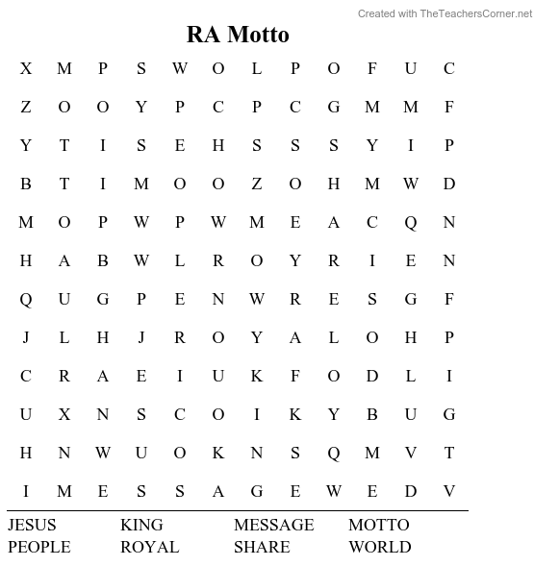

Ambassador Role-Playing Activity Dialogue
This script can be used in a variety of ways.
- You could have an adult be the narrator (this is an excellent way to involve a dad).
- If you have an older boy who can speak loudly, he could be the narrator.
- You could have the boys read the parts and then act them out.
- If you have boys who can learn the lines and speak them, that could be an option.
- There is also the possibility of explaining the scenario and then letting them come up with their own script and actions.
Assemble and secure any props you are going to use (robes, crowns, thrones, invitation box, blue paper/cloth representing water, brown paper/cloth representing mountains, etc.). Feel free to use your imagination! You want this to be effective, but you must still maintain a safe environment for the boys.
Select the boys to be the main characters. Be sensitive to those who may seem hesitant to get involved. Don’t force the issue, but maybe later they will want to become involved. Be sure to communicate that everyone has a part; some may be a king, but all are citizens of the kingdom.
The characters you will need are:
- A King of ____________ (Stan).
- A King of ___________ (Lee).
- An Ambassador ____________ (Juan).
- A narrator (if you are using one).
- Citizens of each kingdom.

Narrator: As our story opens, we see the great and mighty King of _______ (Stan) sitting on his throne in all of his glory. Across the mountains (or water), we see the King of ________ (Lee) seated on his throne before the citizens of his kingdom. As we listen in, we hear the King of Stan talking with one of his court officials (Juan).
________ (King of Stan): I have been thinking. I want to be good friends with our neighbor, the King of _______ (Lee). I think it would be a good thing if I sent someone to their country to represent us in case the King of _____ (Lee) or any of their citizens has a question about our kingdom. _____ (Juan) would you be willing to be our ambassador to the Kingdom of ____ (Lee)?
_________ (Juan): Yes, your majesty, I would be honored to represent you and to be your ambassador to the Kingdom of __________ (Lee). What message would you have for me to share with them?
__________ (King of Stan): _______ (Juan) I would like for you to live among them and share our story with them.
___________(Juan): Yes, King, I will be willing to do that.
__________ (King of Stan): ________ (Juan) I want to have a great party to celebrate my son’s birthday. I will send a letter inviting the King of ______ (Lee) and all of the people in his kingdom to the celebration. (King makes writing marks on a paper, signs the invitation, rolls it up, puts it into the carrier and hands it to _______ (Juan).
_________ (Juan): Yes, King ________ (Stan), I accept the challenge and will deliver your message.
________(Juan) carries the message through/over the water/mountains and delivers it to King ______ (Lee).
_________ (Juan): Greetings, King _______ (Lee) from my king, King ______ (Stan). I want to deliver this invitation to the great party that my king is giving to celebrate his son’s birthday.
________ (King of Lee): unrolls the message and pretends to read it) Thank you. Please extend our thanks to your king for his generous offer. We will be glad to attend and celebrate the king’s son’s birthday. _______ (Juan), please come and stay here at my palace so that you may represent your king.
_________ (Narrator talking to the group of boys and men): Will you accept the challenge to share the message of Jesus Christ with the people of your kingdom?
“We Are Ambassadors for Christ”— 2 Corinthians 5:20

This page is intentionally left blank.

Teaching Through the Royal Ambassador
Motto and Pledge
Lesson 2 – Royal Ambassador Pledge Line 1

The Royal Ambassador Motto
“We are ambassadors for Christ”
– 2 Corinthians 5:20

The Royal Ambassador Pledge
As a Royal Ambassador I will do my best:
to become a well-informed, responsible follower of Christ;
to have a Christlike concern for all people;
to learn how to carry the message of Christ around the world;
to work with others in sharing Christ; and
to keep myself clean and healthy in mind and body.

Lesson 2 – Royal Ambassador Pledge Line 1

“to become a well-informed, responsible follower of Christ”
(Ideas for possible answers are in italics.)

As the boys arrive
10 to 15 minutes — this means before the meeting starts.
Spoon fight: Each player, two at a time, holds a tablespoon in the hand opposite the one normally used. Place a ping pong ball, tennis ball, or similar object in the spoon’s bowl. On a signal, each player approaches his opponent and, using his other hand, tries to knock the object out of his opponent’s hand. They cannot use any other part of their body. They can use the same hand to defend against the other player’s attempt. When someone loses their object then two more boys will try.

Opening
For Lads, have them repeat the RA motto. For Crusaders, have them repeat the RA Pledge. Have them repeat the pledge to the United States and Christian flags. Read the names of missionaries who have birthdays and pray for them.
(Most children today know little about geography. If you have a world map let them find the countries or states on the map so they’ll know where the missionaries are serving. And they will also learn about Gods world when He calls us to help Him.)

Business
5 to 10 minutes
(We recommend electing officers every quarter so different boys can hold leadership roles.)
You can have a notebook to keep the minutes in. The President can read the minutes from the last meeting. If the President is absent, the Vice President will. Have a chapter roll, and the Secretary can mark those present or absent. The leader can discuss upcoming activities the chapter or church will be doing, etc.

Meeting Feature
30 to 40 minutes
We will be discussing the RA Pledge over the next weeks. Today we will talk about how to be a “WELL-INFORMED, RESPONSIBLE FOLLOWER OF CHRIST.”
We are Royal Ambassadors. An ambassador represents a leader of a country or the people of that country. As Royal Ambassadors we represent Christ Jesus.
If we are to represent Jesus, we must know Him and all we can about Him. Jesus chose 12 disciples and they walked with Him, talked with Him, had their meals with Him, and at times camped out under the stars with Him for 3 years. During that time, they learned how to represent Him to the world.
With this knowledge and His comforter, the Holy Spirit, with them, they went everywhere they could, sharing and teaching all they had learned from Him.
The most important thing they learned was to share with those they talked to how they could have their sins forgiven and become a member of the Kingdom of God and how Jesus’ teachings could help them live a life that pleases God. Jesus taught not only how to please God, but how to have a happy and joyful life.
As a Lad/Crusader you are on that same journey as the disciples of learning all you can about Jesus and how God can use you as His Royal Ambassador.
Can you think of some ways you can learn about the Lord and how to be His Royal Ambassador? (Let them answer the question first before you go on.)

- Sunday School: When you study the Bible and all the great stories about God’s people and their experiences it will help you to become informed. (example: David, Jonah and the whale, Jesus feeding over 5,000 with a boy’s lunch, Jesus paying the price for our sins on the cross of Calvary, Easter and the resurrection, Peter, James, John, Paul, etc.)
- Church Worship: Listening to God’s Word being preached by the pastor.
- Music: The choir and special music about the Lord.
- RA Camp: With Bible studies, singing, preaching, camp fire services.
- RA Chapter Meetings: Where you will do mission studies about how we help people in our city, state, country and all over the world. But not only will we hear about others on mission, but we will DO things for others together as a RA Chapter. We will be able to help others more and more as we learn how and as we become well-informed followers of Christ.
That is why it’s so important to become as well informed about being an on-mission Christian as we can. This is something we will learn to do as RAs.
Each step you take as an RA will make you more informed. Each step will help you to do a little more for Jesus and to help others in His name.
When you took your first math class and learned that 1 + 1 = 2 and 2 + 2 = 4, you were not ready to know why x + y = 9. You had to learn one part of math at a time. RAs will take you one step at a time to be a “WELL-INFORMED, RESPONSIBLE FOLLOWER of Christ.”
As a RA chapter we will all learn together one step at a time, we will help each other, support each other and lift up each other. And we will have a lot of fun along the way.
The Bible makes it clear that the principles we learn from God’s Word are to be part of all phases of our lives. “My son, keep my words and store up my commands within you. Keep my commands and you will live; guard my teachings as the apple of your eye. Bind them on your fingers; write them on the tablet of your heart.” (Prov. 7:1-3).
As a RA we will become well-informed about the Lord’s plan for our lives.

Leader time
about 5 minutes
God knows all about everything even before it happens. A few years ago, God invited Texans on Mission (then called TBM) to be in a partnership with Israel to teach its volunteers how to prepare and serve large numbers of meals in a disaster. In October 2023, an enemy attacked and killed many people in Israel. The war left many homeless and hungry. Within 24 hours TXM had teams in Israel to help feed the hungry.
Those they had been training were informed about what needed to be done. In just the first few weeks of the need to feed the hungry and hurting people, TXM had fed over 50,000 meals. When TXM went in, it also brought in 50 medical people to help.
It’s hard to imagine 50,000 meals. How much food is that? I want you to take on an assignment to report back to the chapter next week. Ask the cafeteria manager at your school how many meals they make each day for lunch. Then divide that number into 50,000 and see how many days it would take your school to serve that many meals. If you have not learned how to divide, ask your parents to do it for you and explain why you want to know. And you can tell them how TXM fed that many people in just a few weeks in Israel.
Just remember, for Texans on Mission teams to be able to do this they had to learn and be informed about it before they could do it. God is always teaching men and women in TXM how to do missions and help hungry people all over the world.

Closing Prayer Time
Close by taking prayer requests. You can write them now in the chapter notes and keep track of the results. That way when a prayer is answered you can check it off and add that praise in the closing prayer. It will reinforce to the boys how important it is to pray for others and how God hears and responds to our prayers. Even when they don’t go just the way we want them to we can help them understand God always knows more than we do about the need and will always be a part of the best end result.
(Remember – make the lesson plan on the level of your boys. Use words they can understand – for first graders it has to be simpler than for sixth graders.)

This page is intentionally left blank.

Teaching Through the Royal Ambassador
Motto and Pledge
Lesson 3 – Royal Ambassador Pledge Line 2

The Royal Ambassador Motto
“We are ambassadors for Christ”
— 2 Corinthians 5:20

The Royal Ambassador Pledge
As a Royal Ambassador I will do my best:
to become a well-informed, responsible follower of Christ;
to have a Christlike concern for all people;
to learn how to carry the message of Christ around the world;
to work with others in sharing Christ; and
to keep myself clean and healthy in mind and body.

Lesson 3 – RA Pledge Line 2

“to have a Christlike concern for all people”
(Ideas for possible answers are in italics.)

As the boys arrive
While the boys are arriving, fold some construction paper into a card to decorate later.

Opening
- Open with prayer.
- Say the RA Pledge together.
- Memory verse:
  - This is my command: Love one another as I have loved you.
— John 15:12 (CSB)

Meeting Feature
Tell them we will be learning about the second part of the pledge.
To have a Christlike concern for all people
Ask the RAs, what does it mean to have a Christlike concern for all people? Give them some time to answer.
Start your Bible study by having three boys read the verses John 15:12-14 (CSB):
¹² “This is my command: Love one another as I have loved you. ¹³ No one has greater love than this: to lay down his life for his friends. ¹⁴ You are my friends if you do what I command you.”

Virtue Explanation

Friendship:
Jesus tells us to love one another just as He loved us. Jesus came to this world to be our friend. He loved us so much He came to show His love by being our friend and dying on the cross for our sins so we would be saved and spend eternity with Him. We need to be a friend to all people to share salvation and show His love.

Compassion:
Jesus always took the time to heal the sick. He feeds the hungry in spirit and physically. He gave hope to the weak and the poor. Jesus showed compassion to all people. How can we show compassion?

Closing
Have the boys talk about how the RA group can be a friend to those who need a friend and have compassion toward those who need help.
Example:
- Be a friend to that boy in school who sits alone at lunch.
- Be compassionate with your neighbors who might need a little help. Help the elderly load or unload groceries, clean their yard. Always ask God to give you an opportunity to be Christlike to all people.
- Tell the boys the best way to show God’s love is by being a friend and showing compassion.

Activity
Make some get well cards to send to people you know are sick.

This page is intentionally left blank.

Teaching Through the Royal Ambassador
Motto and Pledge
Lesson 4 – Royal Ambassador Pledge Line 3

The Royal Ambassador Motto
“We are ambassadors for Christ”
— 2 Corinthians 5:20

The Royal Ambassador Pledge
As a Royal Ambassador I will do my best:
to become a well-informed, responsible follower of Christ;
to have a Christlike concern for all people;
to learn how to carry the message of Christ around the world;
to work with others in sharing Christ; and
to keep myself clean and healthy in mind and body.

Lesson 4 – Royal Ambassador Pledge Line 3

“to learn how to carry the message of Christ around the world”
(Ideas for possible answers are in italics.)

Objective
The Royal Ambassadors will understand and grow in ways to
“Carry the Message of Christ around the World.”

Lad memory verse:
Go therefore and make disciples of all nations, baptizing them in the name of the Father and the Son and the Holy Spirit.
— Matthew 28:19 (NASB)

Crusader memory verse:
but you shall receive power when the Holy Spirit has come upon you and you shall be my witnesses both in Jerusalem, and in all Judea and Samaria and even to the remotest part of the earth.
— Acts 1:8 (NASB)

Challenger memory verse:
For the grace of God has appeared, bringing Salvation to all men. Instructing us to deny ungodliness and worldly desires and to live sensibly, righteously and godly in the present age, looking for the blessed hope and the appearing of the glory of our great God and Savior, Jesus Christ; who gave Himself for us, that He might redeem us from every lawless deed and purify us from every lawless deed and purify for Himself a people for His own possession, zealous for good deeds.
— Titus 2:11-14 (NASB)

While the boys arrive
There are additional optional activities at the end of the lesson.

Puzzles
Lead the boys to paste a large, colorful picture of a person or place a missionary might serve on a piece of poster board. Download pictures from NAMB, IMB or Mary Hill Davis websites. Help the boys cut the board into 20 to 25 pieces. Make several puzzles. Take turns putting different puzzles together. Store in plastic bags. Mark so they can be used at different times.

Opening
At the end of the lesson there are a couple of variations to open the meeting to tie in with carrying the message of Christ around the world. Most of the times in my group we open with the pledges and missionary prayer calendar. These can be added to the opening.

Words from a Missionary
Read Ephesians 2:10 (Living Bible), “It is God Himself who has made us what we are and has given us new lives from Christ Jesus; and long ago He planned that we should spend these lives in helping others.” Paul, the first missionary said:
God made us what we are.
God gave us new lives from Christ Jesus.
God’s plan is that we spend our lives helping others.

Meeting Feature/Counselor’s Time
This example is from Roland Harvey:
Take the boys on a short nature walk. Have them each collect one rock. Explain to the boys that missionaries live in many places. Have the group choose two rocks from the ones collected. Have the boys name the two rocks. Examples: Chip, Stoney, Flake, Rocky or other names.
Write a letter to a missionary or missionary kid that you have these two rocks from your church. Their names are Chip and Stoney. Chip would like to stay with you, but Stoney doesn’t like to travel alone. Ask the missionary to send Stoney back and enclose a rock from where they minister. When the rock returns put it on the map where the missionary lives. Have the boys pray that the missionaries will be able to carry the message to the people they work with. Keep track of how many times the chapter sends Stoney and a partner on a “missionary journey” and the places Stoney dropped off partners to share the message.

Questions for missionaries
Missionaries have many ways to communicate with them by internet. Have the boys prepare questions for missionaries that they can share through the internet.

Mission Projects
There are many ways to support missions in your group. Many organizations need help with water purification. Texans on Mission Water Impact ministry has ways the boys can support it through prayer and giving. The older Challengers can plan a World Changers mission trip or just do a ministry in the neighborhood like mowing grass or trimming trees.

Missionaries in your church
Many churches have people who have carried the message of Christ around the world. Have the missionaries share about their trip and how the boys can pray for the state or country. You can provide the boys with a flag from the state or country as a reminder to pray.

Closing

Praying for missionaries
Lead the boys to pray for at least one of the missionaries mentioned in the meeting. Remind them of the needs and work mentioned in the stories and the lists they helped you develop during the meeting. Lead in prayer or let a boy who volunteers lead. Pray that the boys learn to carry the message of Christ around the world.

As the boys leave you can play hymns sung by groups from different countries.

Additional Options

Optional Activities for while the boys arrive:

Seven Coins
Place any seven coins on a surface in this pattern:

1
2
3
4
5

Goal: Remove two coins and leave five in a row both vertically and horizontally.
(Solution: Pick up 1 and 5 and stack them on 3.)

Cups and Pennies
Place three paper drinking cups in a row and a pile of 10 pennies nearby. The trick is to put the pennies into the cups so that each cup holds an odd number of pennies.
(Solution: In Cup A, three pennies. In B three pennies, In C four pennies. But wait, set cup B inside Cup C. Now cup C holds seven pennies.)
Optional Opening Activities:

My own missionary
Have the boys sit in a circle in chairs. Choose two boys who will sit on opposite sides of the circle to lead the saying of the RA Pledge in unison. Pass out slips of paper with the names of missionaries who have birthdays on them. Ask each boy to pray silently for his missionary. Then ask the boy who has volunteered to lead in prayer to do so. Following the prayer ask the boys with home missionaries to go to the map and point to where their missionaries serve. Repeat for international missionaries on a world map.

Witnessing for Christ
First Boy: Reads John 3:16
Second boy: Says, “Lost people live in our community.
God loves them. Do we?”
Third boy: Reads Acts 1:8
Fourth boy: Says, “Jesus said begin at home to witness, then go out into and around the world. Have we been faithful?”
Fifth boy: Says, “Let us say in unison the Great Commission found in Matthew 28:19-20.”

After saying the Great Commission, each boy is given a slip of paper to write the names of one or two boys from their neighborhood or school. Each boy is asked to pray for and tell at least one boy about John 3:16 this week.

You can play the song, “The Commission,” for prayer time.

This page is intentionally left blank.

Teaching Through the Royal Ambassador
Motto and Pledge
Lesson 5 – Royal Ambassador Pledge Line 4

The Royal Ambassador Motto
“We are ambassadors for Christ”
— 2 Corinthians 5:20

The Royal Ambassador Pledge
As a Royal Ambassador I will do my best:
to become a well-informed, responsible follower of Christ;
to have a Christlike concern for all people;
to learn how to carry the message of Christ around the world;
to work with others in sharing Christ; and
to keep myself clean and healthy in mind and body

Lesson 5 – Royal Ambassador Pledge Line 4

“to work with others in sharing Christ”
(Ideas for possible answers are in italics.)

As the boys arrive
Make salvation bracelets — 2mm beads in black, red, white, blue, green and yellow/gold; 2mm leather string 8 inches long for each one; discuss each color, what it means, and read the verses associated with the different colors:

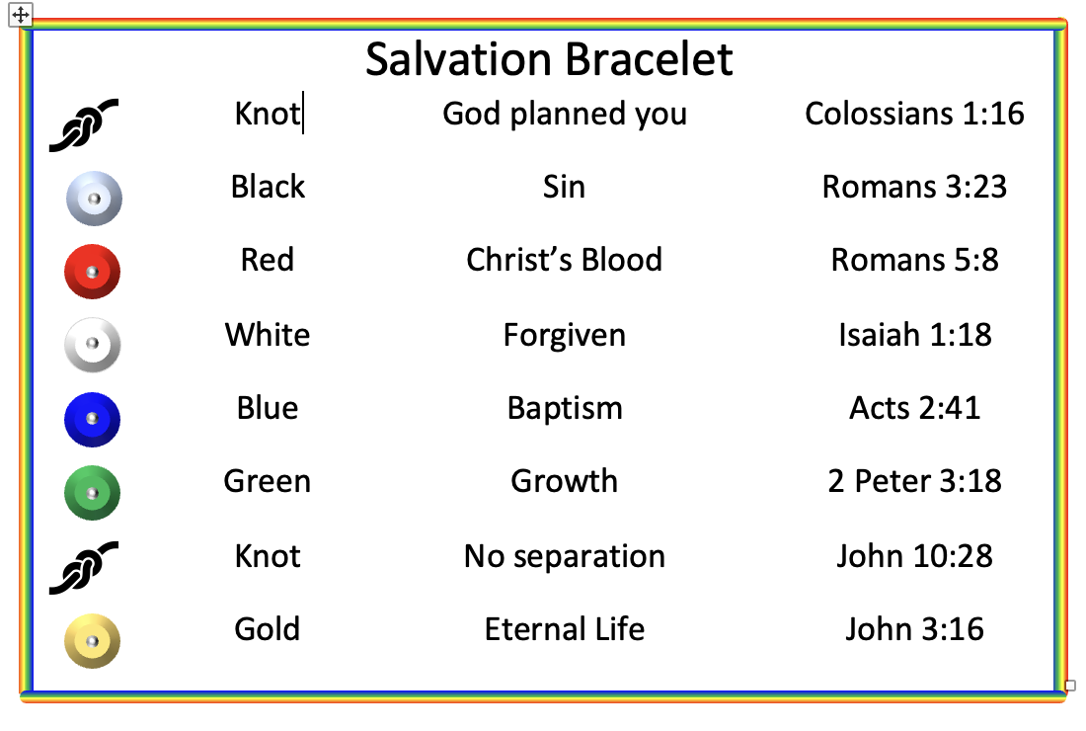

Opening
Say the RA Pledge together, saying that we will talk about the fourth line today — To work with others in sharing Christ.
Take roll of the boys in attendance letting them know they are all important to God.

Meeting Feature
Fishing for Friends, Matthew 4: 18-22; Jesus used ordinary guys (fishermen) to help spread the Good News. Even though fishing for food was a way of life for these men and the way for them to support their families, they left everything to follow Jesus. Could we do that?
Have a boy read Matthew 4:18-20. What did the men do? Did they know Jesus or had they heard about Him — why did they drop everything and GO with Him?
Have another boy read Matthew 4:21-22. Where were two more that did the same thing? What was it about Jesus and His calling to them? What do you think the men thought at first and why did each one follow Jesus, without peer pressure?

Leader time
The salvation bracelets you made at the beginning — one for you and one to give to someone else that you share the Message — are a great way of Fishing for Friends. In Matthew 28:19-20, Jesus said GO, and each of us can GO. He also PROMISED He would be with us ALWAYS, so we should never fear or be worried about the results of our sharing the colors and their meaning. Encourage them and any adults to use this tool.
Ask the boys if they have any questions about sharing or what to do in certain situations. We are not to preach, but to share.

Closing
Cross and latch/say the RA Motto and pray.
Cross and latch, forming a circle, having each cross one forearm over the other and hold the hand of each neighbor (latch).

Resources

Activity # 1
If you know an avid fisherman, have him/her come and talk about fishing, demonstrating the casting process by hooking a magnet on the end of the line and casting into a hula hoop where there are people cut outs with paperclips attached. Have the fisherman discuss how it takes finding a good fishing hole, preparing the gear and having patience after casting. The same things are true about fishing for friends/people. We need to prepare by praying for others, making new friends and then when the time comes telling him/her about Jesus and how He can forgive them and save them. With that salvation, each person will live eternally in Heaven.

Activity # 2
Have each boy try casting with extra pole(s) that were prepared during activity #1 or before the chapter meeting.

Discussion Question:
Was it easy “catching” a fish? If we did not catch one, did we stop? No, we wanted to go again. God wants us to continue to fish regardless of the results. Once we share the Gospel, the Holy Spirit will take it from there. We should always work to love that person as God does.

Teaching Through The Royal Ambassador
Motto and Pledge
Lesson 6 – Royal Ambassador Pledge Line 5

The Royal Ambassador Motto
“We are ambassadors for Christ”
— 2 Corinthians 5:20

The Royal Ambassador Pledge
As a Royal Ambassador I will do my best:
to become a well-informed, responsible follower of Christ;
to have a Christlike concern for all people;
to learn how to carry the message of Christ around the world;
to work with others in sharing Christ; and
to keep myself clean and healthy in mind and body.

Lesson 6 – Royal Ambassador Pledge Line 5

“to keep myself clean and healthy in mind and body”
(Ideas for possible answers are in italics.)

Bible Verse
Present yourselves as living sacrifices, holy and acceptable to GOD.
— Romans 12:1

Meeting Feature

Not Eating a Meal Fit for a King
Daniel 1:1-20
Daniel, along with several other young men, including his friends, Shadrack, Meshach and Abednego, were carried off to a foreign country after their country was conquered in a war. These young men, just a little older than RAs, were chosen by the new king to be trained as government officials in this new country.
As part of their training, they were given special meals prepared by the new king’s people. The young men knew that these foods were not the type that were healthy for them. They also knew eating such food went against what GOD would want them to eat. Daniel asked the guard who brought them the king’s meals if they could have other foods to eat. The guard said he feared for his life if Daniel and his friends did not eat the food he had brought for them.
Daniel made a deal with the guard to have him bring them the healthy foods that Daniel asked for. After ten days Daniel and his friends were healthier and in better shape than the other young men. From that time on they received the type of foods they asked for. At the end of their training period, they were the king’s choice to become top officials in his government.
These young men showed self-discipline and honored God by not eating the things they knew they shouldn’t. They were determined to keep themselves clean and healthy in mind and body by following God’s plan for their life.

Leader Time
How did Daniel and his friends show self-discipline in dealing with eating the king’s food?
They had been taught and understood that they were not supposed to eat certain foods that went against God’s plan for them.

There is an old saying that goes like this:
Do what’s right even if you are the only one who does.
Don’t do what’s wrong even if everyone else does.
Did Daniel and his friends follow this principle? How can RAs show they are following Christ in their daily life?

What are some ways that RAs today can try to “Keep myself healthy in mind and body”?
RAs can live out this line of the pledge by eating more of those foods that are healthy and less of those that are not as healthy. RAs can also stay healthy by being active and being involved in physical activity. Reducing the amount of time spent on electronic devices can allow more time for physical activities. An RA can also help to keep his mind clean by being careful about what he listens to, reads and watches.

Bible Verse Fill in the Blank
“Present ______________ as ______________ sacrifices,
________ and acceptable to _______”
Romans 12:1

Word Search
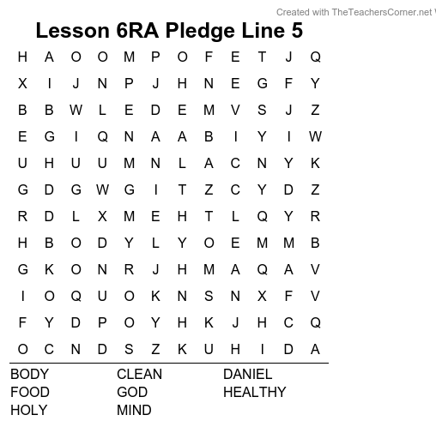

Activity

Soccer Dribble
This activity is taken from the Texas RA and Challenger Mission Mania activity manual.
Equipment needed:
- 1 soccer ball, properly inflated
- 6 stakes or cones
- 1 stopwatch (or a cell phone with that capability)
This activity consists of dribbling a soccer ball around five stakes or cones and returning. Time starts when the ball is first kicked and ends when the ball and the boy are both back past the "start" point. The course will consist of six stakes or cones. The first stake is the "start" point and the sixth stake is 100 feet away. The other four stakes are at 20, 40, 60 and 80 feet in a straight line between the first and sixth stakes. The total distance, as well as the distance between stakes, can be adjusted to fit the space available. The Royal Ambassador must "weave" the ball between the stakes or markers (i.e., if he passes the first stake on his right then he must pass the second stake on his left then the third stake on his right, and so on until he passes the sixth stake and returns the same way). If the RA misses a stake or cone, he must dribble the ball back and around the stake until all stakes or cones are passed in the correct order.

4 Friends Coloring Page

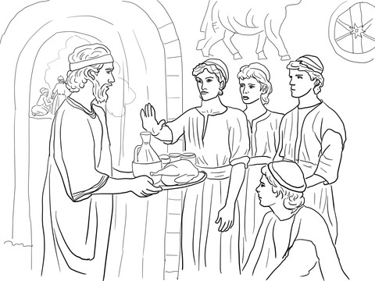

This page is intentionally left blank.



CAIN. The Commission. CAIN - EP, 2019.

